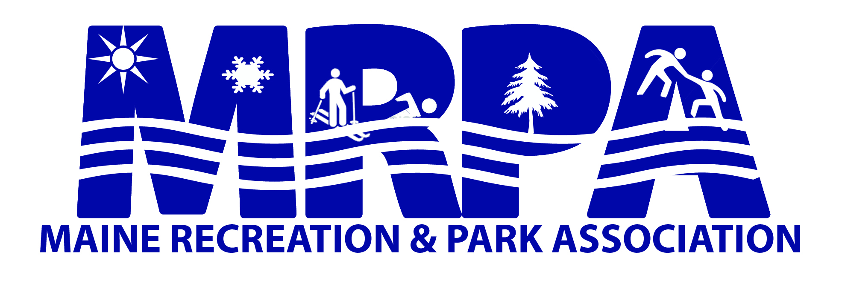

Report of Executive Director for May, 2017

- Weekly updates to membership
- Job posting updates on MRPA web site
- MRPA Track program work
- Emailing and calling MRPA members about 2017 membership
- Hot Shot invoice and report mailed to Red Claws
- Spring magazine
- Fall workshop conference call
- Griffin Clifford – Caribou P & R about scholarship money
- Eblast for MRPA track program
- Tyler Pitch Hit and Run Program
- Winterport Recreation new membershp
- Collecting conference revenue
- Fall workshop room sponsors

Submitted to MRPA Board
May 30, 2017
Deb Smith, Executive Director

