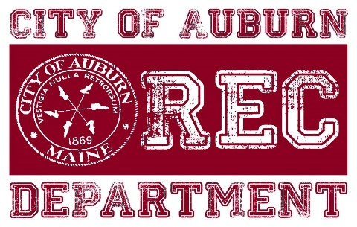**Auburn Recreation**

**Summer Camp 2020**

**COVID-19**

**\*This is a living document and is subject to change as more information becomes available and restrictions change. \***

Given the current Federal and State limitations surrounding COVID-19 the following plan is in preparation of restrictions per the State of Maine’s re-opening plan Phase 2 anticipated start date of June 1. Under Phase 2 Summer Day camps are permitted, following the limit of no more than 50 people gathering, continued social distancing of 6 feet away whenever possible and the wearing of cloth masks when social distancing cannot be obtained.

**Locations** – The plan is to have no more than 40 kids per camp site to allow for staff, cleaning, delivery, and any other persons needing to access a facility. IF the State allows for more than 50 within a larger space or a combo of inside and outside those numbers will adjust (i.e. 50 on one end of a school and 50 on the other, 50 inside and 50 outside, 50 at one end of the park and 50 at another end). Below is a list of locations including additional spaces if needed; if a park is listed there would be restrooms, handwashing stations, and tents for shelter placed in each one:

* Auburn Middle School – Confirmed, Camp 4-6th grade
* Walton Elementary – Confirmed, Camp 1-3th grade
* Park Ave School – Confirmed, Camp Pre-K and K
* Ingersoll Turf Facility – Confirmed, Camp 7-8th grade
* Municipal Beach/Tribou Field – Confirmed, Camp 4-6th grade
* Pettengill Park (baseball field and pond building) – Confirmed, Camp 1-3rd grade
* Tot Lot, Back-up
* Little Edward Park (CLT), Back-up
* Chestnut Park, Back-up
* Mt. Apatite, Back-up
* Pulsifer Park/Field, Back-up

At each of these locations there will be a designated ‘quarantined’ location that will be separate from camp activities. This space is for anyone showing symptoms or signs at camp to segregate them from everyone else and camp areas.

**Health Checks** – Check-in and Drop-off will be designated areas and signage will be increased to avoid the amount of contact with parents and camp areas. When possible, parents will remain in their vehicles and staff will come to the cars to retrieve the kids. Upon arrival at all locations, staff and kids would follow a checklist (Appendix A) which includes:

* Arrival Temperature screen and checklist of symptoms or signs of COVID-19 (and other viruses). Temperatures over 100.4 will not be allowed at camp, camper will be sent home and parents will be asked to monitor for progressive symptoms or to call their PCP for guidance.
* Sanitize personal belongings which will be limited to; change of clothes, backpack, water bottle, lunch box, sunscreen bottles, any medication, and any other items permitted.
* Arrival Washing of Hands
* Wash Hands before and after AM Snack
* Lunch Temperature and checklist
* Wash Hands before and after Lunch
* Wash Hands before and after PM Snack
* Dismissal Temperature screen and checklist
* Sanitize personal belongings
* Dismissal Wash Hands

Hand washing will be the preferred method of sanitizing hands; however, hand sanitizer will be available and used multiple times throughout the day. All campers will be encouraged to sing a camp song that lasts 20 seconds while washing their hands.

**Employee PPE** – All Staff will be required to follow State guidelines of wearing a cloth mask while at camp as social distancing cannot be guaranteed. If they are on break or in a space where they are alone and not within 6 feet of anyone, they do not need to wear a mask. Staff will be provided masks (3) if they do not have their own. If the masks are cloth they must be washed after daily use. Staff will not be required to wear gloves unless preforming an activity such as cleaning, health checks, and other. Staff will be required to follow the same Health Checklist as the campers for monitor of symptoms, temperatures, and cleaning of hands and is encouraged to use hand sanitizer as much as possible throughout the day.

**Campers PPE** – Summer Rec Camps are considered childcare providers and are exempt from requiring kids to wear face masks. However, it will be recommended that cloth masks are used at camp except for when they are eating or getting a drink and are 6 feet away from everyone. Auburn Rec will be provided 1 mask to each camper with additional masks for sale and cloth masks must be washed daily. Campers will be required to follow the Health Checklist for cleaning of hands and will be encouraged to use hand sanitizer as much as possible throughout the day. Campers will be required to have a water bottle every day; water fountain use will be limited unless filling a bottle. (Auburn Rec is unsure if a water bottle will be provided). Water Bottles should be cleaned daily. Auburn Rec may provide a sling bag for each camper to keep overnight at camp locations which can have a change of clothes, towel, and other items to help decrease the number of items being brought between camp and home.

**Cleaning** – A professional cleaning service will be used once a week (if not more) for all indoor locations or outdoor locations with bathrooms. Staff will perform daily cleaning with approved wipes on all major touch points in addition to normal daily cleaning routines (trash, re-stocking paper goods, sweeping/cleaning of the floors, etc. Daily cleaning will be logged on specific area sheets. Staff will be required to use gloves while cleaning. All efforts will be made to eliminate shared equipment such as basketballs, hula hoops etc. with the whole camp. This company will be on-call incase of a confirmed case or outbreak for cleaning needs. Camp Cleaning and PPE supplies needed: Surgical disposable masks, gloves, hand soap, EPA approved cleaners, hand sanitizer, hand washing stations, approved surface cleaning and disinfectant wipes, paper towels, cleaning spray bottles and other.

**Trips and Bussing** –Big trips such as Funtown, Jokers, Sea Dogs Game, etc. have already been cancelled for Summer 2020. IF busing is provided via the school department, camp will follow their guidelines for social distancing. If allowed, camp will continue to have a beach day but will adjust which groups go which days to limit the number of kids on the bus and at the beach. If allowed, camps will do more local trips such as Mt. Apatite, Lost Valley, Tot Lot, Hiking Trails etc. All efforts will be made to transition trips into a guest at camp such as Mr. Drew and his Animals. Any guest at camp will be required to follow the same health screen upon arrival and will be asked to monitor their health using the pre-camp screening. Guests will not have contact or interactions within 6 ft of campers and will perform in a concert style to maintain proper distancing. Cleaning of major touch points after a guest has left camp will be logged.

**Hiring and Training** – To date there is 30 summer camp staff looking to return from last year. A few interviews have been conducted and everyone (new and returning) have been given verbal commitments pending State guidelines. No Temporary Employment Agreements have been issued at this time. These agreements already have language in there stating they are ‘at-will’ employees and positions are pending if the program occurs and successful background checks. The City’s lawyer is working on language to add to all paperwork and forms pertaining to COVID-19 (for employment documents and forms for parents). All normal hiring protocols will be followed such as Interviews, background checks, reference checks, temporary employment agreement signed, all payroll documentation, then lastly training. Normal protocol of asking last years staff if they planned on returning was followed and begun in March. Returning staff are required to fill out new background checks and any payroll documentation required by Human Resources. Training week is planned for June 17-19 and will include the normal topics along with the addition of The Red Cross Mental Health Training, New protocols and procedures around cleaning and health checks, and any others required. Staff is exploring the potential of online training in the form of a webinar but no decisions have been made at this time. Staff will be training in case tracking, to help educate them on how the infection spreads and questions that may be asked if there is a case at their campsite.

**Nurse** – A new position has been created in response to COVID-19, Camp Nurse. This position will serve as the on-site/call medical staff. Responsibilities will include Health Educator for staff and campers, inventory of all medical supplies and equipment, oversee’ s daily health of campers and staff, monitors health screens and keeper of health checklists. The Nurse will be doing daily check-ins at each camp and will be on call for any evaluations needed outside of emergencies. Right now the Camp Nurse would be required to use their own vehicle to travel from camp to camp and will be given a mileage reimbursement, but no final decision has been made at this time. This position must be licensed as a registered nurse or working towards a nursing degree (second year students preferred). This position will work with the City’s Safety Coordinator to maintain all procedures and protocols are being met along with any potential signs of a confirmed case or outbreak.

**Activity and Equipment** –Each Camp will be broken down into smaller groups following camper to counselor ratio’s (1:6 Pre-K, 1:8 for 1-6th grade, 1:10 for 7-8th grade). These small groups will each be given their own activity equipment bag such as basketballs, hula hoops, etc. When possible, each child will be provided their own activity kit (coloring items, jump ropes, hula hoops, etc.) whenever possible. These will be the same items to avoid cross contamination whenever possible. All items within each group’s activity kit will be sanitized before and after use. A cleaning checklist will be kept in each activity box to ensure this step is being followed. Camp leaders will use CDC approved activities provided by Asphalt Green’s “REP it out from a Distance” program. It is critical to be able to ‘trace the path’ of potential contamination when a confirmed case is present. Having a routine, specific daily schedule, designated space, areas, equipment, and potential interactions will be extremely helpful to trace the path of potential spreads.

**Lunch, Lines, and Bathrooms** – Lunch will be eaten outside as much as possible with designated group areas and each camper maintaining 6 feet from anyone. This will allow for their masks to be removed while practicing social distancing. Breaks and Snacks will be handled in the same manor. If inside for lunch groups will each in separate areas and campers will be assigned an area that is 6 feet from each other. Whenever possible, lines will be avoided such as breakfast and lunch will be brought to them vs. lining up to get them from kitchen staff. Spots on the floor/ground will be placed 6 feet away for when lining up to go outside, inside head count etc. If in a situation where already established spots are not available, staff will be provided cones/markers to quickly establish line spots. Each group will be assigned a designated stall and bathroom time to avoid cross contamination as much as possible. Knowing kids can be very unpredictable with bathroom use, staff will attempt to clean major touch points as much as possible throughout the day. When possible, hand sanitizer will be placed at bathroom entrances to be used before entering.

**Playgrounds** – Waiting on further guidance from Maine CDC and NRPA on how best to include or not include playgrounds in camp activities. If playgrounds are allowed, they would need to be opened to campers ONLY and not the public. Daily cleaning would be performed before and after each group within camp goes to use playground.

**Preventing Cross Contamination** – All efforts will be made to keep groups confined to contact within their own groups. Each group will be assigned their own location/area for everyday storage, play, and lunch. The hope is that when a case is confirmed the contact can be limited to one group and there will be an already identified path of potential travel for the virus. Normal activities have been adjusted to eliminate the amount of interaction and physical contact within groups. Example less tag and more relay races, shadow tag, or flag football.

**Preexisting Medical Conditions –** Campers with preexisting medial conditions will be allowed to join camp and will work with the camp nurse and site directors on how best to handle camp activities and precautions i.e. no running activities, always wears mask when inside, parents will be called to be picked up anytime a suspected symptom is reported etc.

**Procedure if symptoms are shown –** Staff will adhere to any guidance or recommendations made by DFC or Maine CDC at any point during symptoms, potential case, confirmed case, or outbreak. Communication to the correct people/professionals will be key if there are symptom’s shown. Child will be required to put on a mask, clean hands and go directly to the quarantined designated room separate from the rest of the camp while the camp Nurse is called (if not already on site) to evaluate the camper. The Nurse will be in contact with the Deputy Fire Chief (DFC) about possible COVID symptoms and together they will decide if the camp needs to go into “lock down” mode or if the camper just needs to be sent home for further observation. Director will be in contact with the child’s parent and ask if the parent can come ASAP to remove the child from camp. Always err on the side of caution as being dehydrated may present similar symptoms as COVID. DFC will decide when Maine CDC should be notified and will handle that communication. The Following steps will be dependent on the severity of the symptoms. Child showing symptoms are asked to stay home until symptoms have subsided and for at least 24-48 hours. We will also require signed copy from their PCP allowing them to return to camp (? – depending on recommendation from DFC).

**Procedure if confirm case** – If a parent or employee notifies camp of a confirmed case, the camp will automatically go into Lock Down Mode, the Deputy Fire Chief will be called along with Recreation Director. DFC will notify the Maine CDC and staff will adhere to their guidance and recommendations on following steps. A pre drafted communication will be sent out to that specific camp with guidance and steps to monitor at home. A different communication will go out to other camps not directly affected for any possible siblings or cross contamination that could have occurred outside of camp. Confidentiality will be followed and tracing the potential contamination path and individuals will be put together.

**Procedure if outbreak occurs** – Will follow guidance from Maine CDC and DFC on appropriate measures. Professional Cleaning company will be called and have 24 hours to clean the space. Depending on the severity of the outbreak, camp may reopen once Maine CDC allows. This step may include everyone being tested or everyone self-quarantining for 14 days.

**Procedure if someone within a household is a confirmed case or being asked to quarantine (Siblings)** – The employee or camper will not be allowed at camp while someone within their household has a confirmed case or being asked to quarantine. They can return to camp if they are no longer staying in the household AND have a negative test result or signed doctor’s note saying they are able to return to camp. If that scenario is not possible the individual can not return to camp until the confirmed case is no longer active and is in recovery mode, completing the 14 day quarantine.

**Lock Down Mode** - If symptoms present are severe or there is a confirmed case, the decision to go into Lock Down Mode will rest with the Deputy Fire Chief. Lock Down mode consist of everyone in camp to put on a mask and sanitizing of hands, groups will report immediately to their ‘home base’ for a quite activity while counselors begin cleaning all major touch points and ‘path’ of the specific camper or group. Campers parents will be notified to come pick up their child and will be given appropriate directions for the situation; monitor for further symptoms, call PCP, self-quarantine, get tested etc. The Professional cleaning company on call will have 24 hours to clean the space.

**Paid Sick Time –** On March 18, 2020, the President signed into law the Families First Coronavirus Response Act (FFCRA). The Act provides temporary relief for those affected by the Coronavirus outbreak. This new Act is effective April 1, 2020 and is in place until December 31, 2020. If an employee is asked to self-quarantine at any point during the summer, they will be paid their normal hours regardless if contracted at camp or outside of work. If it is deemed the exposure was contracted at camp, then a first report will be filled out and sent to HR to follow workers comp procedures.

**Communication –** Communication with parents via text app “Remind” and direct email chain with the Program Coordinator for each camp site. We have a “Summer Camp” Facebook that we will post all camp information. All Site Directors, Camp Nurse, and Program Coordinator will provide parents a phone number for communication. We will ask parents to program these numbers into their phones if possible, so they know when camp is calling. Above in “Procedure if symptoms are shown” we go over the call tree for communications. Any communication pertaining to COVID related items will be provided both verbally and in written forms and will include additional steps or precautions to take at home. Safety will be the number one priority during camp and the lines of communication from parents and households to camp and vise versa will be critical to having a safe summer camp.

**Attendance/Timecards-** Staff timecards will be done remotely using Google Docs Maps and checks will be mailed. Direct Deposit will be highly encouraged. Camp attendance will be done remotely as well on Google Docs so that the Program Coordinator and Camp Nurse can keep track of staff and campers daily and off site when needed. Directors will be required to enter attendance by 10AM each day listing who is in, who is out and why, who is sick, etc. The Google Doc records will be available if/when there is a case and allows us to keep track of absences and 14 day quarantine. Appendix C shows the Pre-Camp Health Screening will be provided to parents to further keep track of health before health along with the proper forms to allow for camper to come back if they are exposed. We will also require signed copy from their PCP allowing them to return to camp.

**Parent Night and Parent Education** – Parent night will be held virtually this year with each site location providing a pre-recorded tour of facilities. Each site will provide a ‘day in the life of camp’ and walk parents and campers thru the various steps and new procedures. In person meetings will be done by appointment only to ensure proper cleaning is performed between each meeting. Parents are encouraged to help educate campers prior to arrival at camp on the importance to not joke or fake COVID symptoms. Unfortunately COVID related items such as coughing on each other or constant touching will not be tolerated and should be taken seriously. Stressing the importance for personal space and good hygiene will be a priority as they will need this summer to prepare for the Fall when they go back to school. More information will come on this topic in the next week.

APPENDIX A

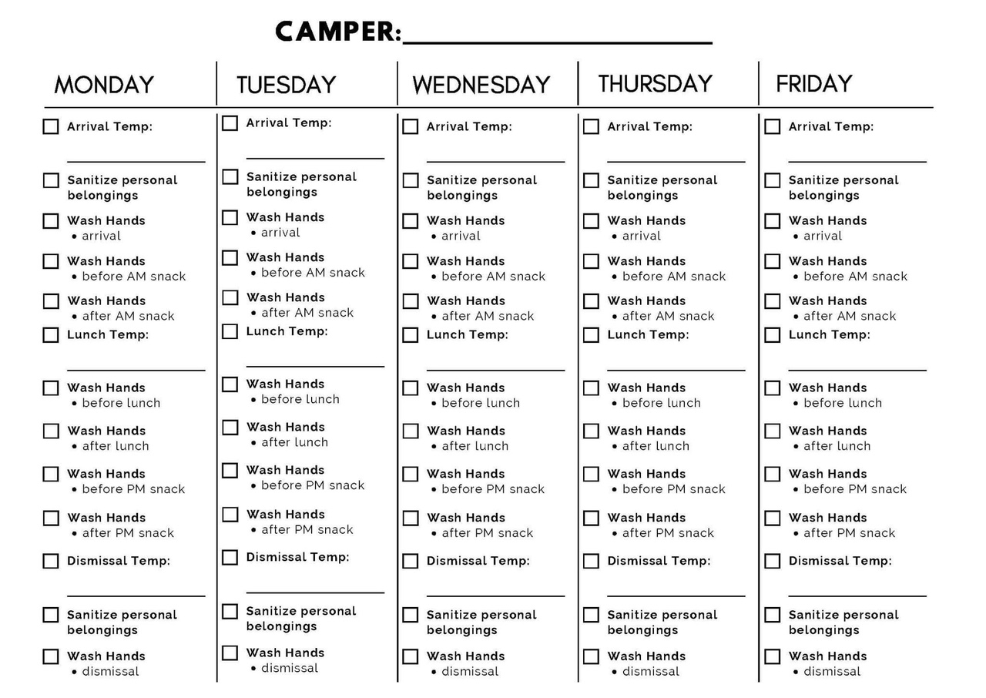

APPENDIX B

PARENT DROP-OFF

* Parents do not need to leave vehicles when dropping off
* ALL drop-off locations will be outdoors (will have 2 if needed)
* Director or Assistant Director will check temperature, if temperature is 100.4 or higher, camper will be asked to go home and monitor symptoms for 24-48 hours.
* Ask the parent/guardian to confirm that the child does not have fever, shortness of breath or cough or any other symptoms.
* Make a visual inspection of the child for signs of illness which could include flushed cheeks, rapid breathing or difficulty breathing (without recent physical activity), fatigue, or extreme fussiness.
* Please put sunscreen on your child before coming to camp and make sure they have their water bottle.
* Designated Counselor will walk children to the bathroom/handwashing station upon arrival
* You do not need to wear personal protective equipment (PPE) if you can maintain a distance of 6 feet.

PARENT PICK-UP

* Sign-out will also be outdoors and provide sanitary wipes for cleaning pens between each use.
* Sign-out sheets will be a separate table in alphabetical order.
* We will still require pick-up person to provide an ID, at least for the first 3 weeks. Then when we become familiar with the parent and then this will no longer be required, unless pick-up person changes.
* Designate a counselor to notify camper their ride has arrived.
* Director or Assistant Director will check temperature, if temperature is 100.4 or higher, camper will be asked to go home and monitor symptoms for 24-48 hours.
* Ideally, the same parent or designated person should pick up the child every day. If possible, older people such as grandparents or those with serious underlying medical conditions should not pick up children.
* If child appears ill, we will call home immediately. Please be prepared to pick up your child within 20-30 minutes of receiving phone call.

APPENDIX C

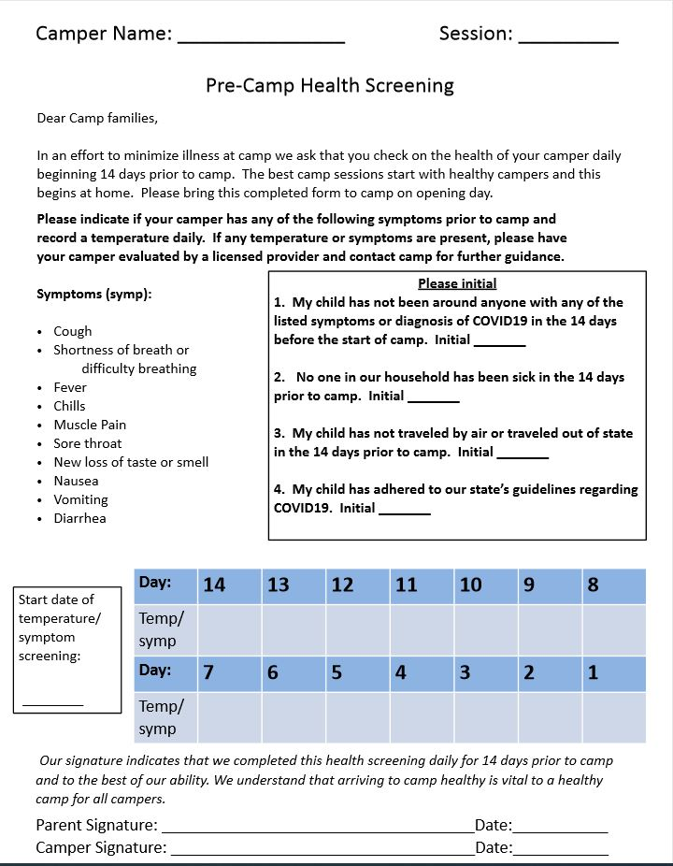

APPENDIX D



APPENDIX E

