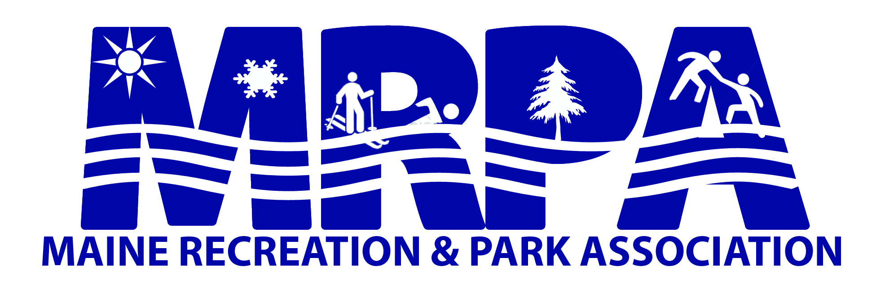

Awards & Recognition

The MRPA Awards & Recognition Committee invites you to nominate a deserving recreation professional, citizen or facility of merit for this year’s reception. It is extremely important to our association to acknowledge people in our profession who are worthy of recognition.

Award recipients will be recognized at the annual
Conference Awards & Recognition Banquet

The application process is the same for all awards. When submitting a nomination for any of these awards, please utilize the Awards Criteria in providing supporting materials for the nomination. If you cannot provide supporting materials for your nominee, please provide contact information of someone who can. The committee will follow up to collect the necessary information.

The final deadline for all award nominations is 45 days prior to the annual conference.

Nominations can be made on-line www.merpa.org

Additional nomination materials can be sent to:
Lisa Thompson, CPRP
Town of North Yarmouth
10 Village Square Rd. North Yarmouth, ME 04097
E-mail: lthompson@northyarmouth.org
Phone: 207-829-5555

2022 Awards Committee Members
Lisa Thompson, Chair
Linda Brooks
Hillary Hallett
Pam LeDuc
Marie Carmichael

Nomination Form

The 2013 MRPA Awards Committee invites you to nominate a deserving recreation professional, citizen or facility of merit for this year’s awards reception. It is extremely important to our association to acknowledge people in our profession who are worthy of recognition.

This year’s award recipients will be recognized at the annual Spring Conference
Awards Banquet at the Holiday Inn by the Bay in Portland on Tuesday, April 9.

The application process is the same for all awards. When submitting a nomination for any of these awards, please utilize the Awards Criteria in providing supporting materials for the nomination.
The final deadline for all award nominations is
Thursday, February 28, 2013.

Please provide a NAME(S) and the associated COMMUNITY for the facility or individual

1) Facilities of Merit Award:___________________________________________________________

2) Citizen Volunteer of the Year Award: _________________________________________________

3) “Dr. Bill Eckart” Young Professional Award:___________________________________________

4) Outstanding Parks Professional Award:_______________________________________________

5) “William V. Haskell” Distinguished Professional of the Year Award: _______________________

___________________________________________________________________________________

After the nomination is submitted, a representative from the Awards Committee will be contacting you for additional information about the nomination(s) that you provided.

NOMINATOR NAME: ____________________________ Job Title: _________________________

Department/Agency Name: _________________________________________________________

Phone: __________________ E-mail: _________________________________________________

Nominations that are not selected in the year in which it was submitted, will be held on file for up to three years for consideration in the future.

Awards & Criteria

- Facilities of Merit Award

- A significant recreation facility established within the last two years
- Shows the project overview, design, plan, and priority of need
- Demonstrates an increase in recreational opportunities – including types of uses
- Local commitment to the project
- Accessibility to users
- Demonstrates innovation and creativity

- Citizen Volunteer of the Year Award

- Contributes to the well-being of recreation within the State of Maine
- A community volunteer who supports the development and creation of recreation programs, facilities or services
- Is not a paid employee of a department
- Length of involvement at the local, multi-town, or state level
- Diversity of involvement, contributions, and achievements
- Letters of support from the community
- Civic involvement
- Moral character

3) “ Dr. Bill Eckart” Young Professional Award

Dr. William Eckart retired from the University of Maine at Machias in 2011 after 31 years as Professor of Recreation Management. During his tenure, he built the program into one of the most respected programs in the country, and it was Maine’s only nationally accredited recreation degree program. Dr. Eckart was an active member of MRPA, serving as Treasurer on the Board of Directors, spearheading the professional certification program, and managing membership.

- Employment History/Experience: The nominee should have minimum of three years working within the Recreation Field and at least a two-year period should have been within the state of Maine, with no more than ten years experience.
- Education: The candidate should have a degree in the field of Recreation, or a related field. Additional consideration will be given to those professionals who have become certified in Parks & Recreation or Therapeutic Recreation.
- Professional Affiliation: Candidates must maintain membership in MRPA. Any additional affiliations will hold value.
- Program Development: Candidates should have demonstrated outstanding performance on a community level through innovative programming, partnerships and civic involvement.
- Professional Involvement: Candidates should exhibit networking skills, and be involved with local and regional recreational issues and committees within MRPA.

- Outstanding Parks Professional Award

- Employment History/Experience: The nominee should have a minimum of 10 years working full time in the parks and/or facilities profession and at least a five-year period should have been within the State of Maine.
- Education: Priority is given to candidates with a degree in Parks & Recreation, or a related field. Additional consideration will be given to those professionals who have become certified in Parks & Recreation (CPRP), Sports Field Management (CSFM), Horticulture (CPH) or certification in related field.
- Professional Affiliation: Candidates must maintain membership in MRPA. Any additional affiliations will hold value.
- Professional Involvement: Distinctive leadership as a parks manager, support staff crew leader, park supervisor, or park ranger in which his/her dedicated service has advanced the organization’s mission or vision.

5) “William V. Haskell” Distinguished Professional of the Year Award
William V. Haskell served the MRPA from its inception and was director of the Presque Isle Parks and Recreation Department from 1946-1981.

- Employment History/Experience: The nominee should have a minimum of 10 years working within the Recreation Field and at least a five-year period should have been within the state of Maine.
- Education and Certification: The candidate should have a degree in Recreation, or a related field. Additional consideration will be given to those professionals who have earned higher degrees and/or who have become certified in Parks & Recreation or related field.
- Professional Affiliation: Candidates must maintain membership in the MRPA. Any additional affiliations, such as NRPA, will hold value.
- Leadership Contribution: Candidates should display qualities of leadership in MRPA and/or NRPA by serving on the Board of Directors or by making other professional contributions such as a committee chairperson, committee member, conference speaker, etc. Ability to communicate vision to others inside and outside his/her organization; execute decision-making aligned with organization's values, vision, and mission.
- Administrative & Program Development: Candidate should have demonstrated outstanding performance on a community level, through innovative programming, facility development and civic involvement.
- Strategic Thinking and Planning:
Ability to develop and implement strategic change initiatives to produce desired change in capacity building, strengthening community leadership, or enhancing the planning process.
- Partner / Coalition Building:
Experience in developing voluntary agreements, cooperative ventures, joint arrangements, alliances, collaborations or coalitions based on common goals to maximize resources for the long-term goals of the organization.
Katahdin Award

- Selected by the MRPA Board of Directors and presented to a Maine elected official or other Maine citizen (serving at the local, state or federal level) who, through their support of park and recreation services or policies at the Local, State or National level, has significantly enhanced the lives of the people of the State of Maine.

